**Optimizing User, Group, and Role Management with Access Control and Workflows**

**Team ID:** NM2025TMID16399

**Team Size:** 4

**Team Leader:** SUMATHI HANNAH. P

**Team member:** VEGANDHIKA. V

**Team member:** VIGNESHWARI. G

**Team member:** PRIYADHARSHINI.S

**PROBLEM STATEMENT:**

In a small project management team consisting of a Project Manager (Alice) and a Team Member (Bob), there is a need to efficiently manage project tasks and ensure accountability throughout the project lifecycle. The current system lacks clear role definitions, access controls, and a structured workflow, leading to confusion regarding task assignments and progress tracking.

**TASK INITIATION**

**Milestone 1 : User**

1. Open the chrome and entering into “developers.servicenow.com”
2. Then use the required email and password to take the project to the next level.
3. You will see a page like this in below.

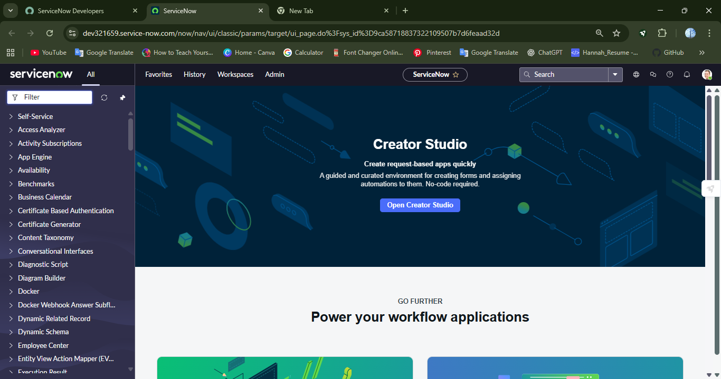

1. Select user from the left side which shows **“ALL”**.

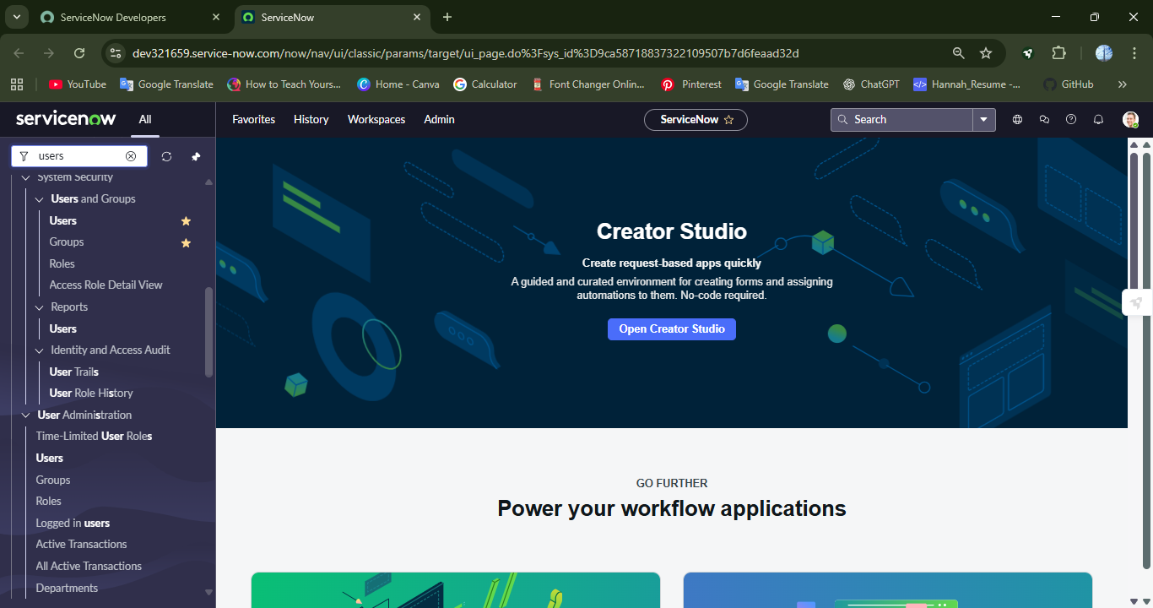

1. After selecting the user under “System Security”.
2. Using the **“New”** in the top right corner.

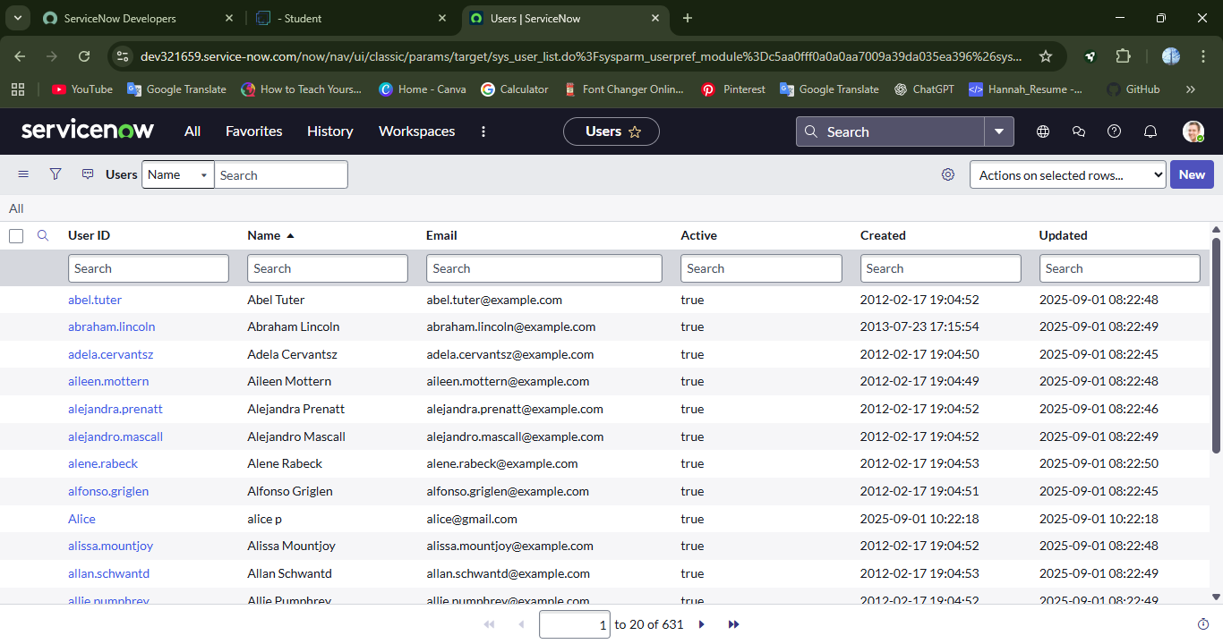

**Activity 1 : Create Users**

1. Filling up the details of the user will be the next step.
   1. User ID : alice
   2. First Name : Alice
   3. Last Name : P
   4. Email : [alice@gmail.com](mailto:alice@gmail.com)
2. Click “Submit” after filling the details of Alice.
3. The user Alice P will be created.

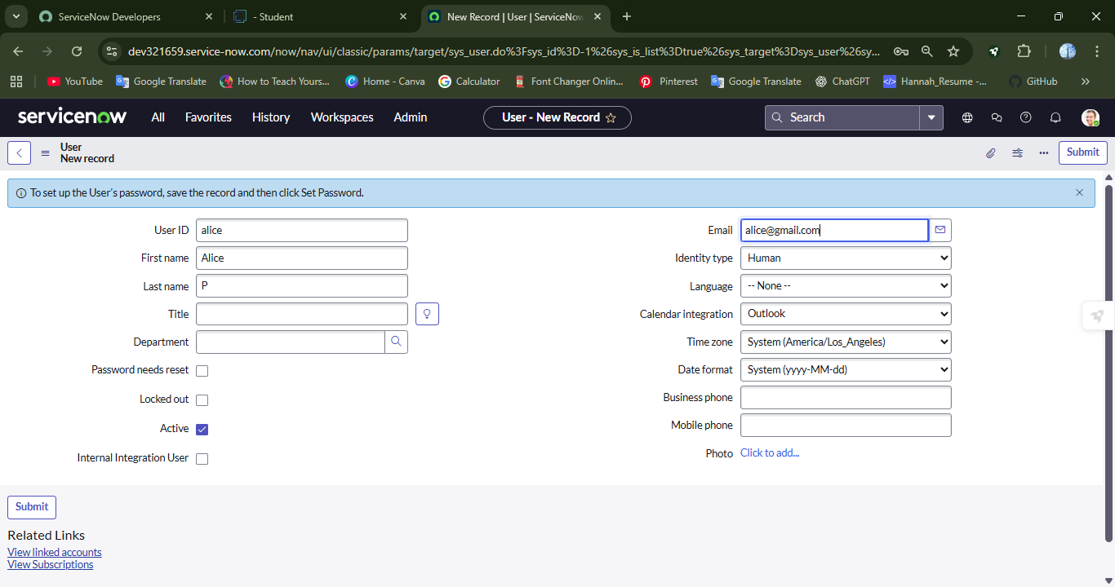

**Create one more user:**

1. Filling up the details of the another new user will be the next step.
   1. User ID : bob
   2. First Name : Bob
   3. Last Name : P
   4. Email : [bob@gmail.com](mailto:bob@gmail.com)

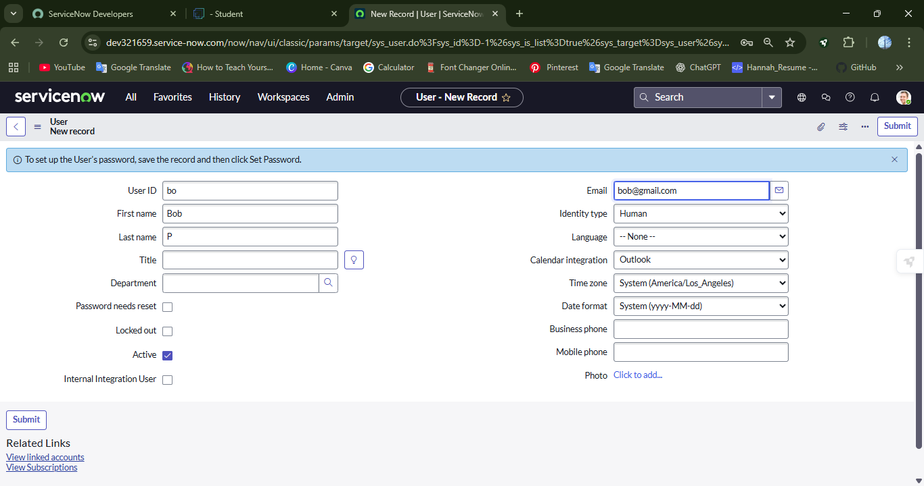

1. Same as the last step, click the submit button after filling the required details of the users.

**Milestone 2 : Groups**

**Activity 1 : Create Group**

* 1. Click on “**All”.**
  2. Search for Groups under “System Security”.

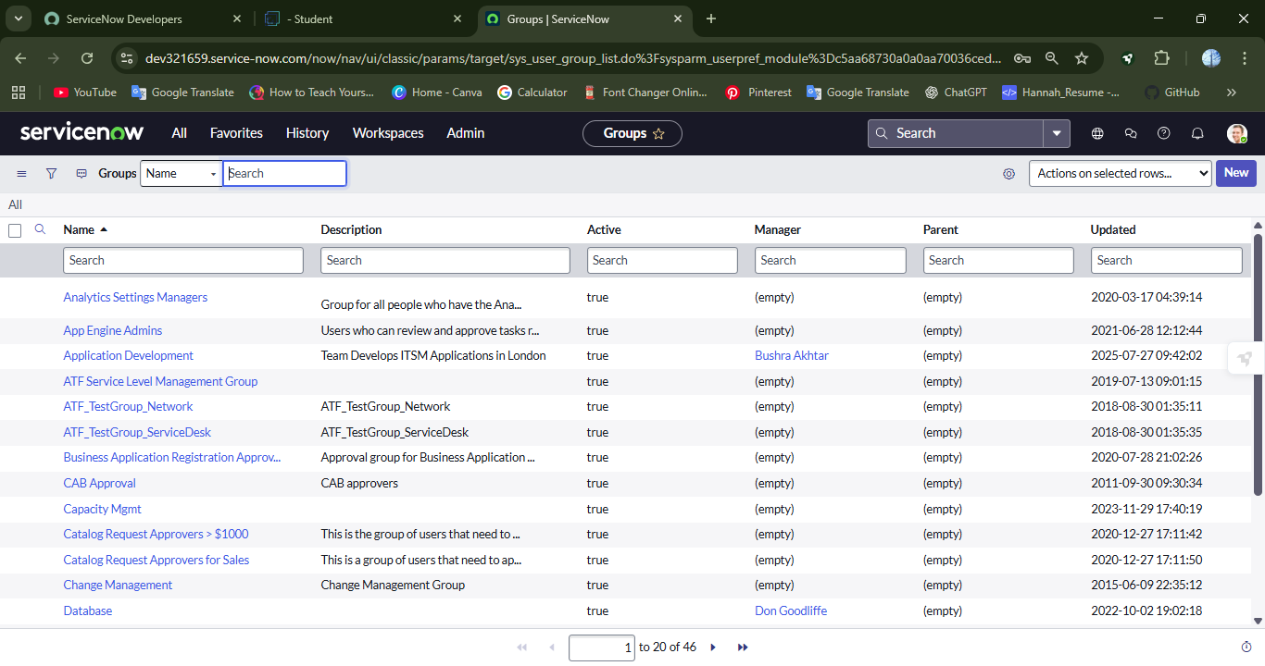

* 1. Click “**New”**
  2. Filling up the details of the user will be the next step

Name : Project team

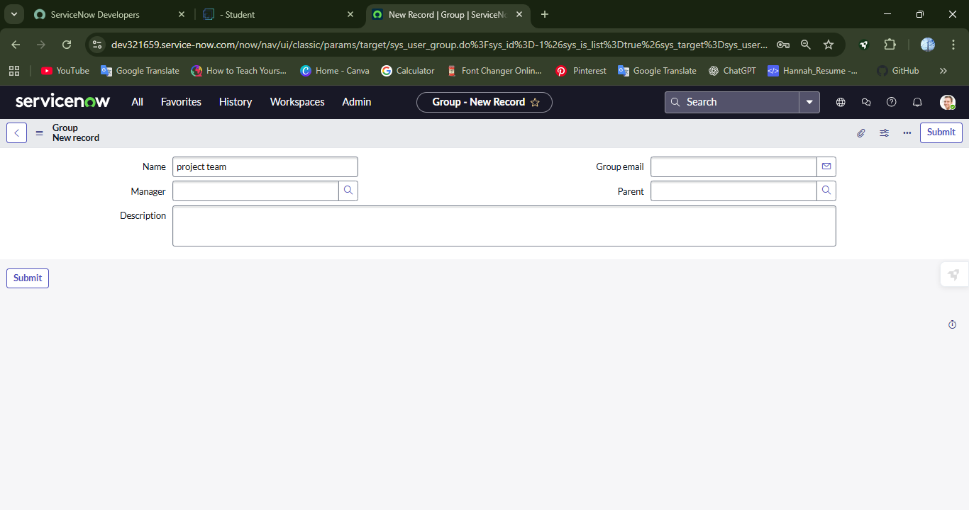

* 1. Click on Submit.

**Milestone 3 : Roles**

**Activity 1 : Create Roles**

1. Click on “**All”.**
2. Search for role under System Security.

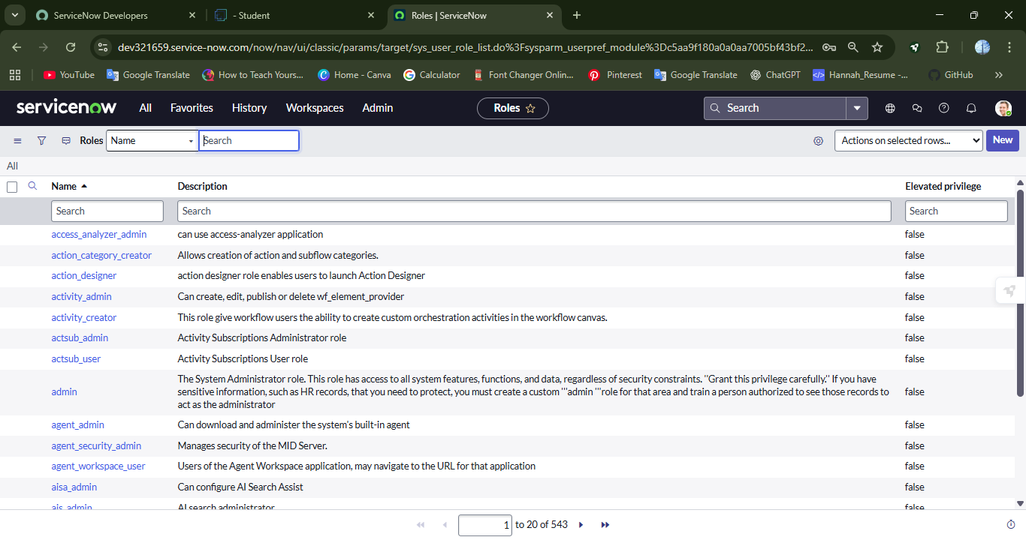

1. Click on **“New”.**
2. Fill in the given below details to create a new role.

Name: Project member

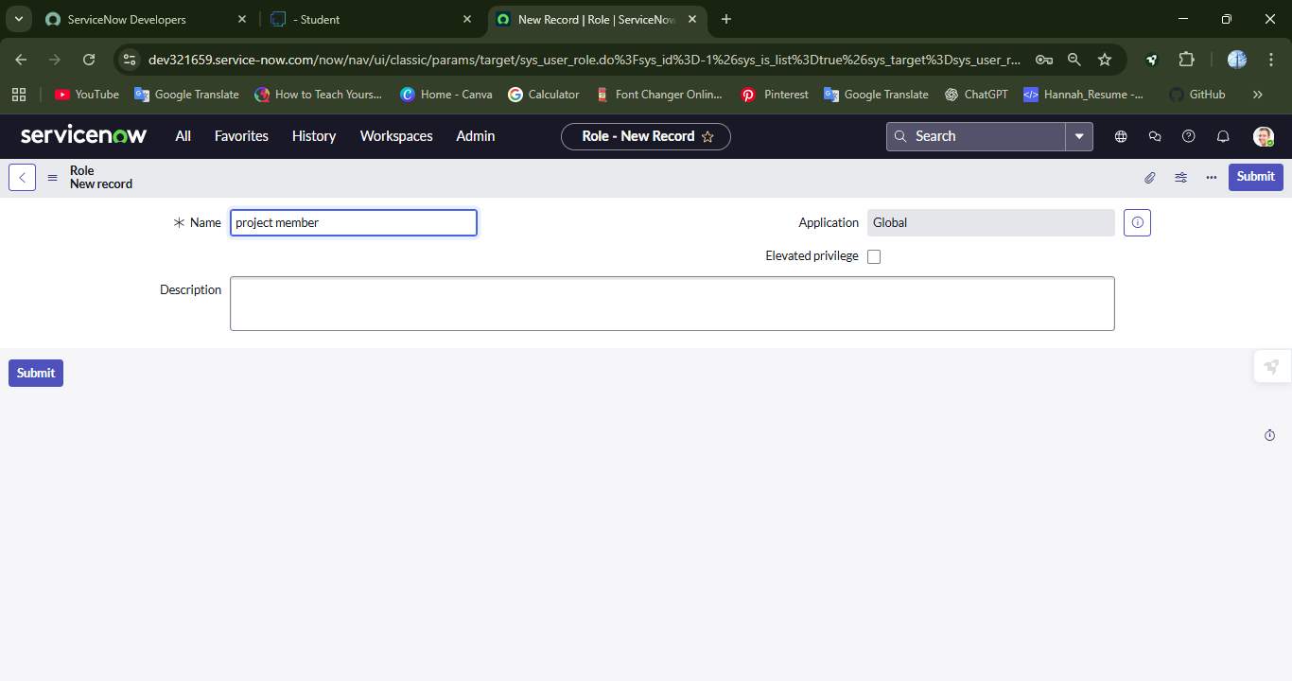

**Create one more role:**

1. Create another role with the following details.

Name : Team Member

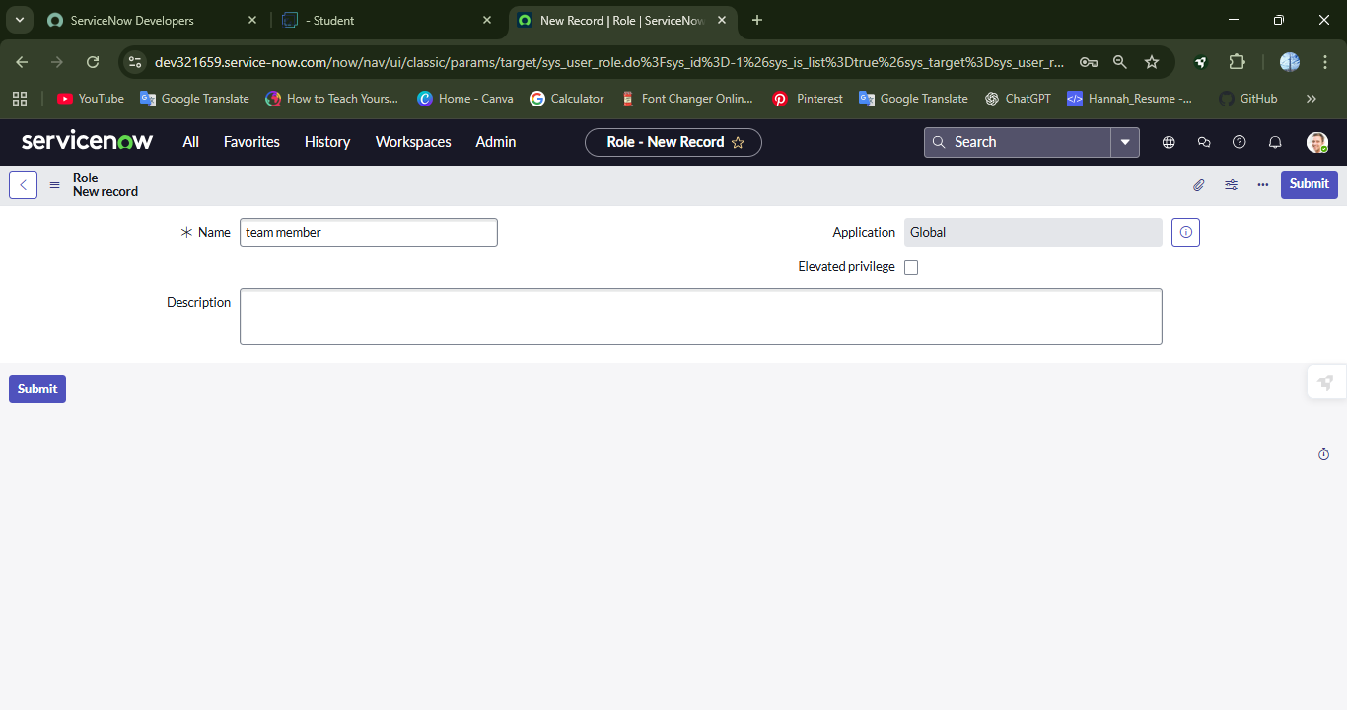

1. Click on Submit.

**Milestone 4 : Table**

**Activity 1: Create table**

1. Click on all
2. Search for tables.
3. Click for **“New”.**
4. Fill the following details to create a new table

Label : Project table.

1. Check the boxes **‘Create Module & Create mobile Module’**
2. Under new menu name : Project table
3. Under table columns give the columns

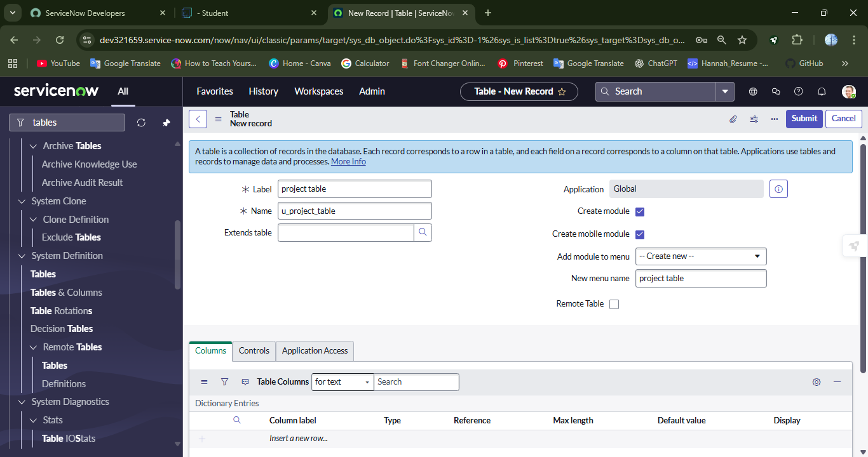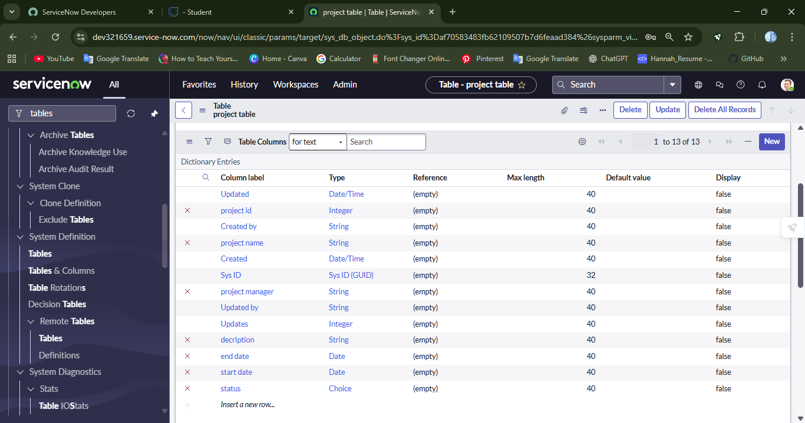

**Create another table**

1. Create another table as : **“task table 1”** and fill in the following details
2. Click Submit.

**Milestone 5 : Assigned users to groups**

**Activity 1 : Assign users to project team group.**

1. Click **“All”.**
2. Search for groups under System definition
3. Select the **“Project team”** group

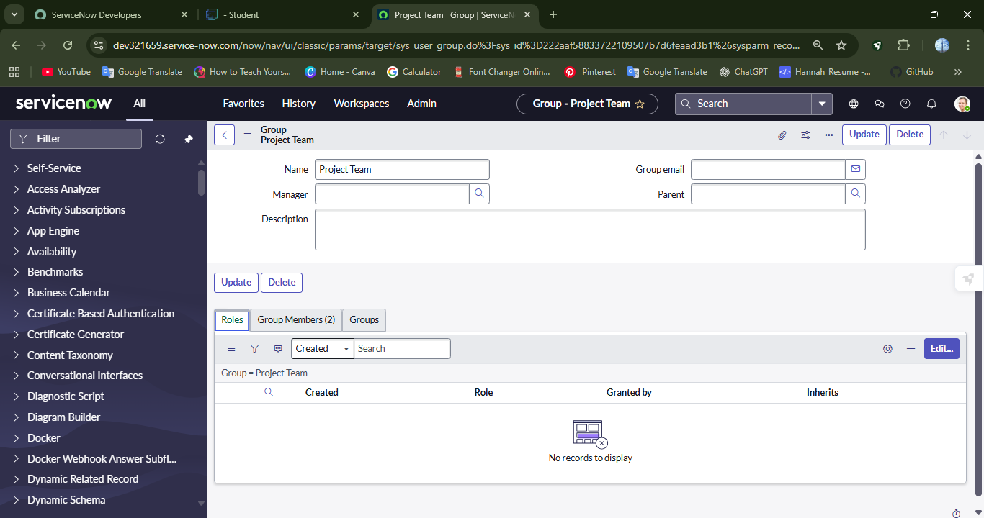

1. Click on Edit.
2. Select Alice P and Bob P

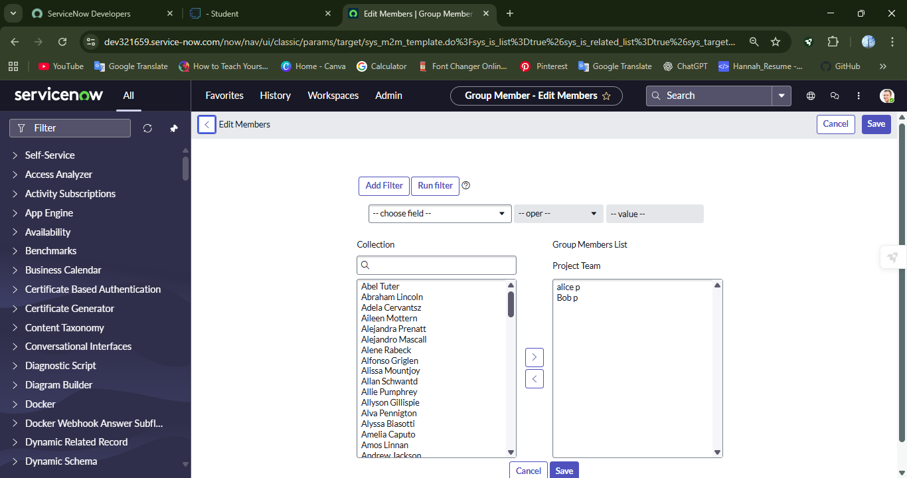

1. Click save .

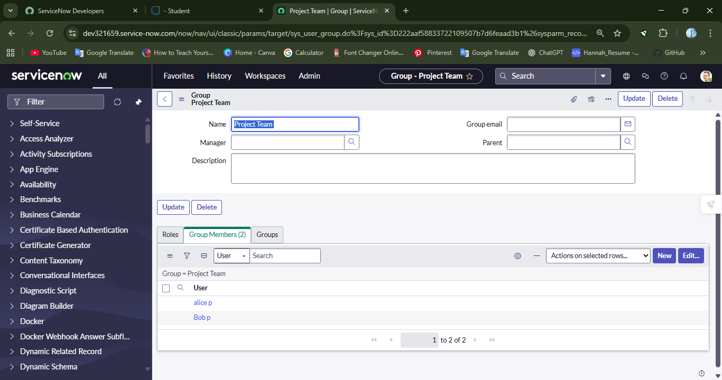

**Milestone 6 :**

**Activity 1: Assign Roles to Alice user.**

1. Click all
2. Select users under System definition
3. Select Alice P >> Roles
4. Select edit and give **“Project member”**

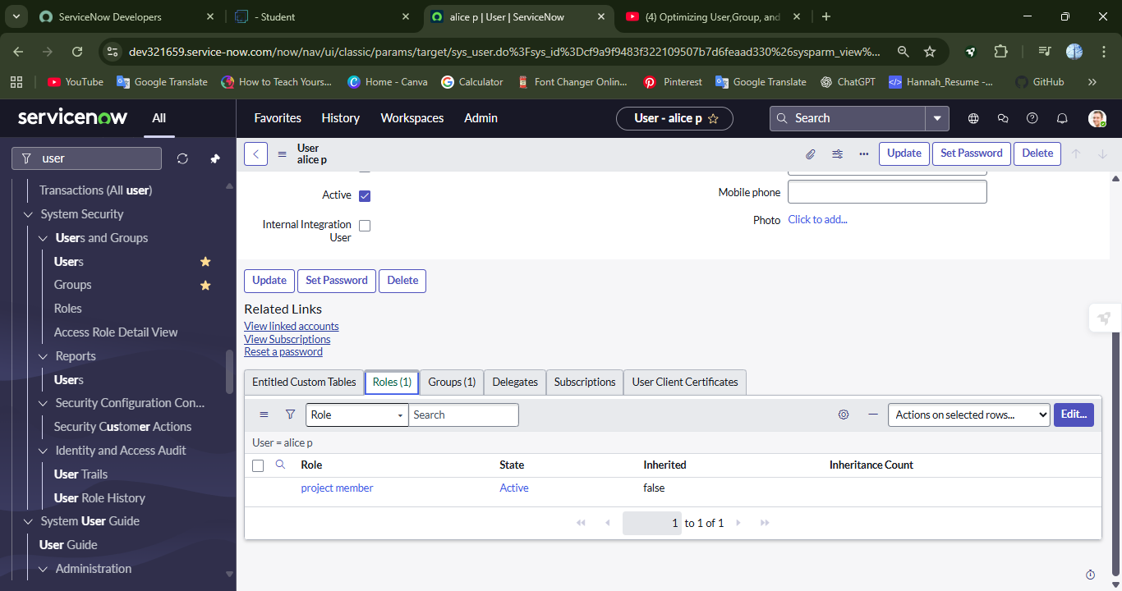

1. Click **“Update”**

**Activity 2: Assign Roles to Bob user.**

1. Search for bob p under users in System Definition
2. Under the roles, click edit,
3. Select “team member”

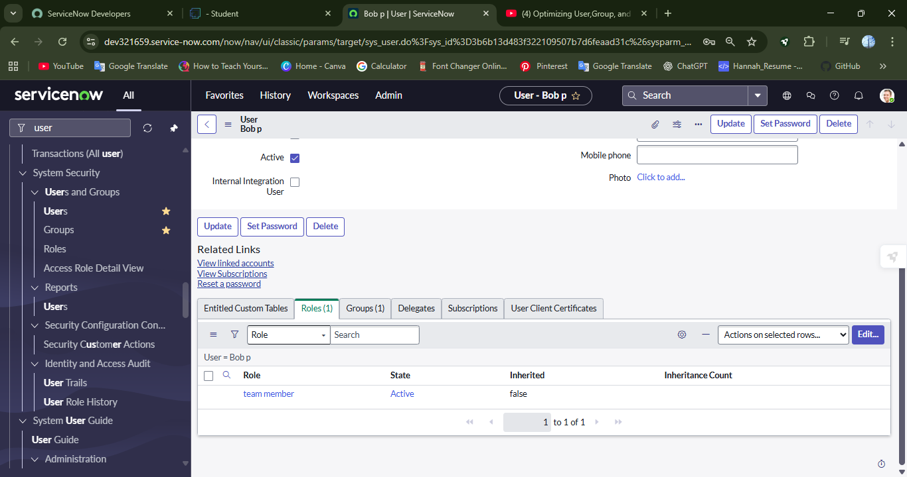

1. Click **“Update”** in the top.

**Milestone 7 : Application Access**

**Activity 1: Assign table access to application.**

1. While creating a table it automatically create a application and module for that table

2. Go to application navigator search for search project table application

3. Click on edit module

4. Give project member roles to that application

5. Search for task table2 and click on edit application.

6. Give the project member and team member role for task table 2 Application

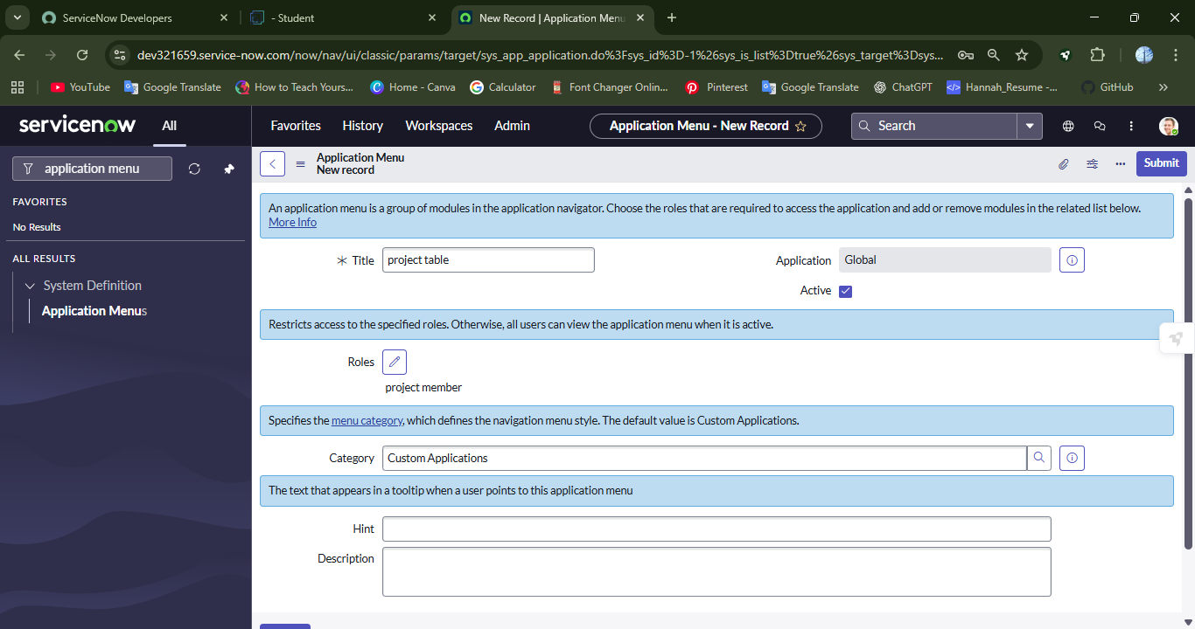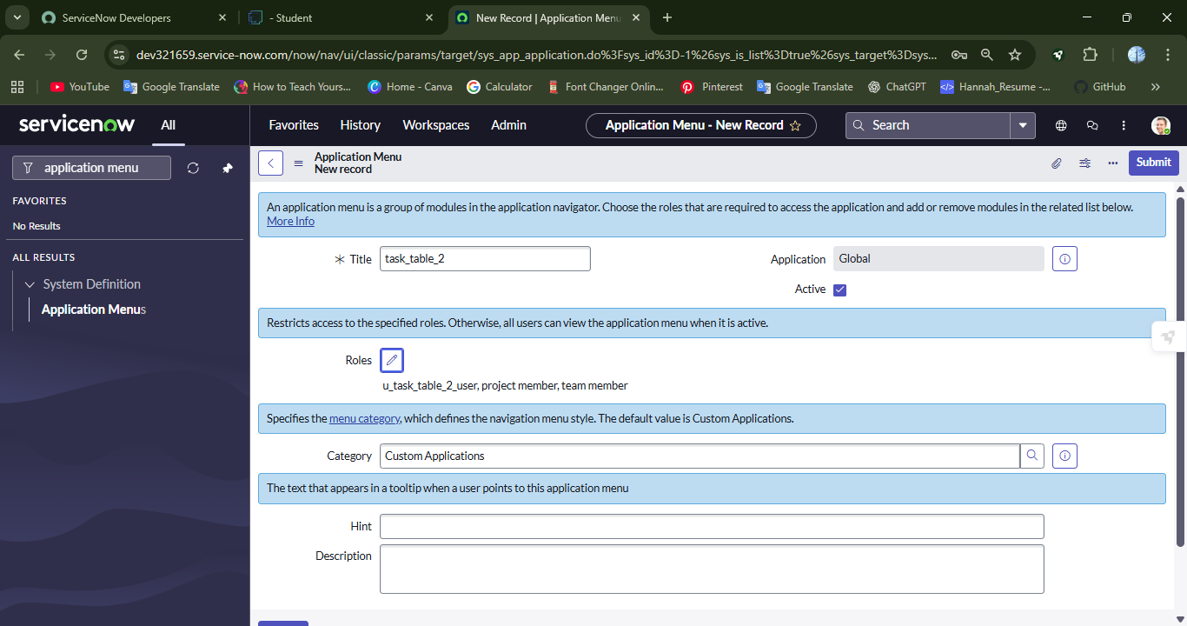

**Milestone 8 : Access control list**

**Activity 1: Create ACL**

1. Click all
2. Search for ACL under System Security
3. Click **“Elevate Role”**

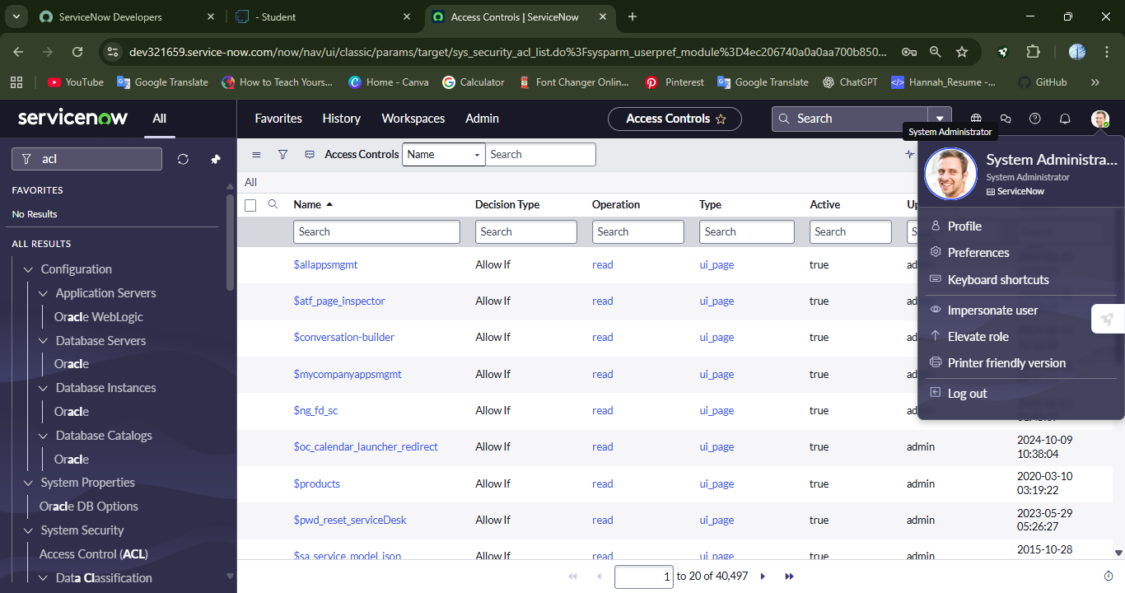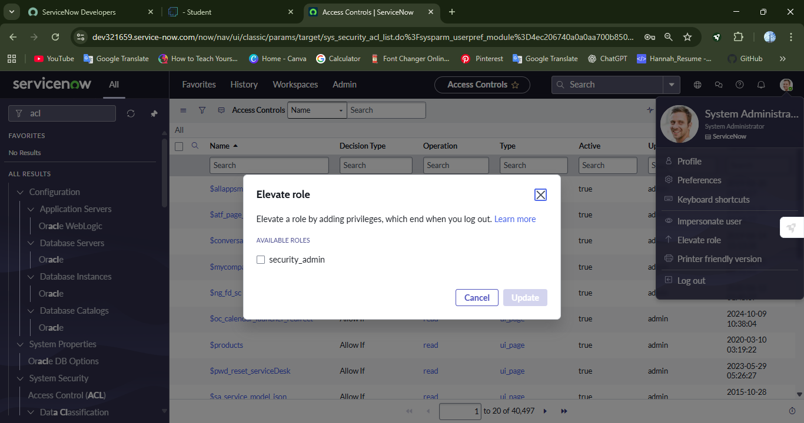

4. Fill the following details to create a new ACL

5. Scroll down under requires role

6. Double click on insert a new row

7. Give task table and team member role

8. Click on submit

9. Similarly create 4 ACL for the following fields

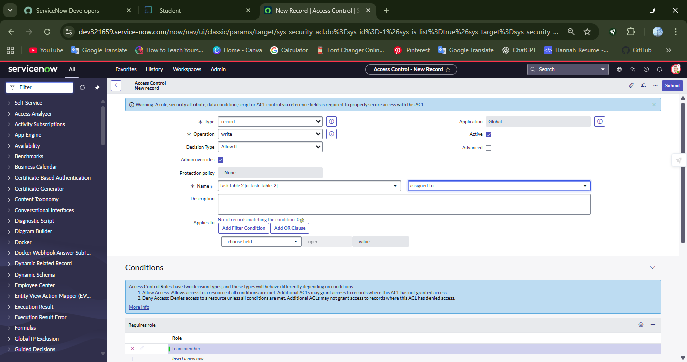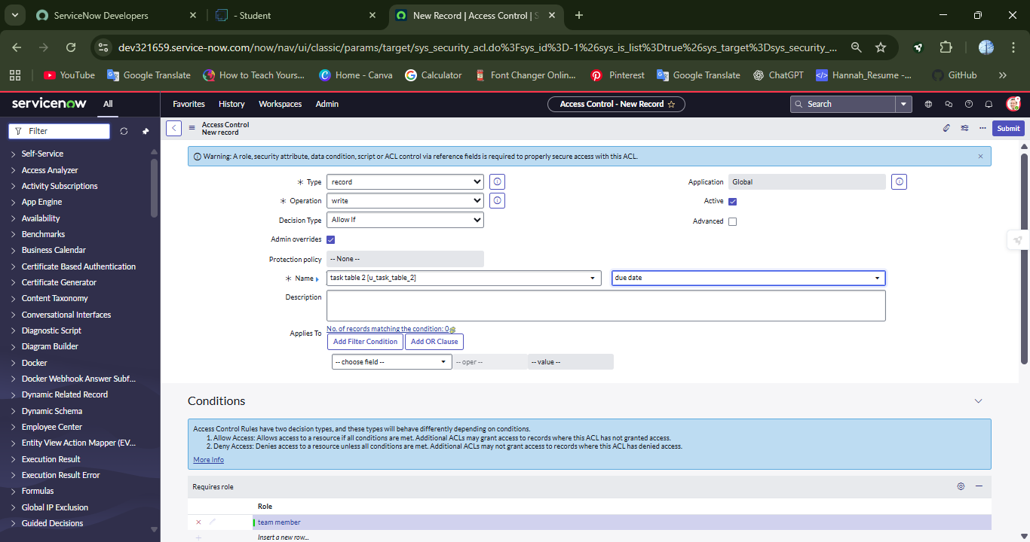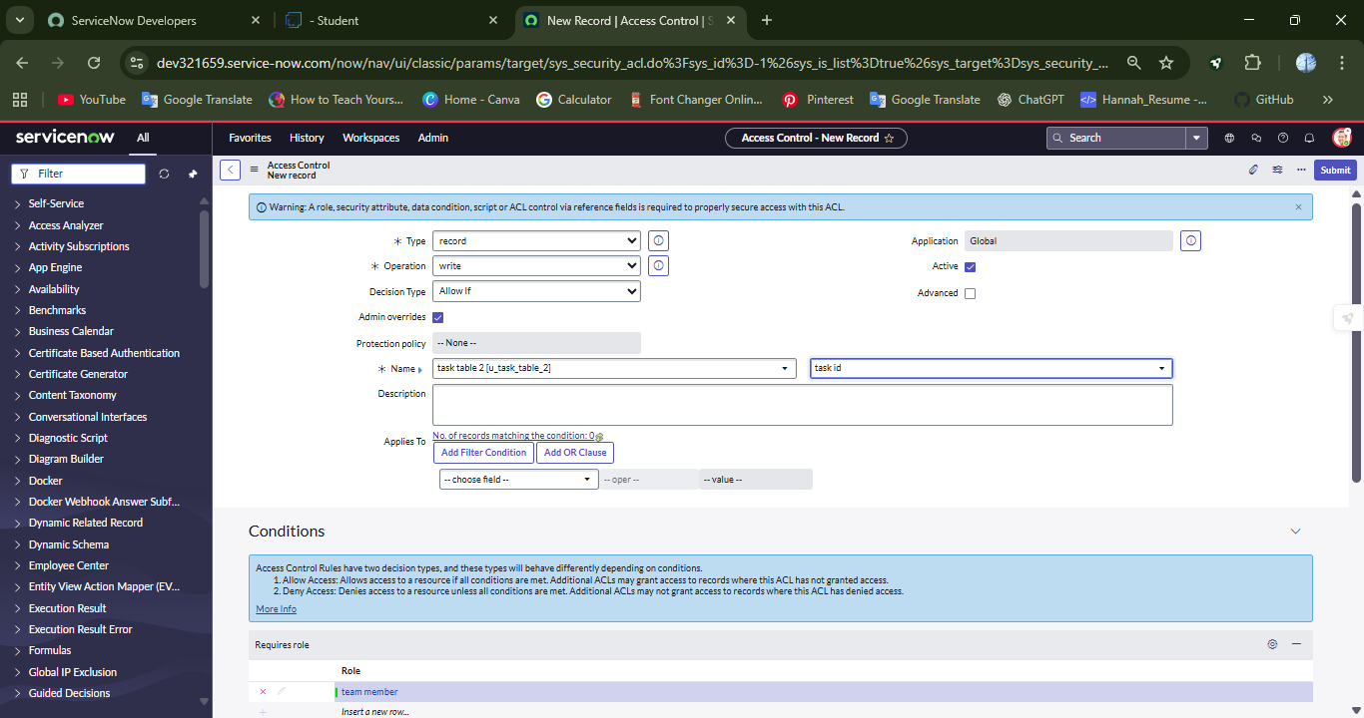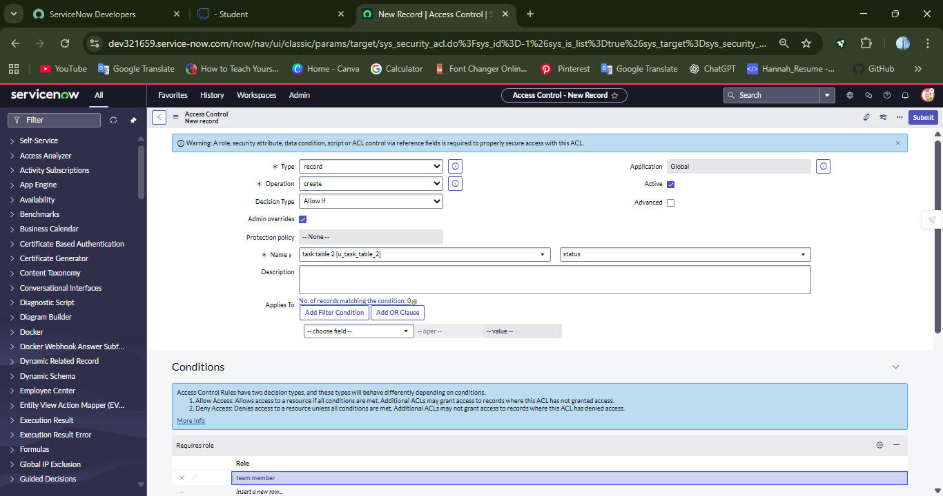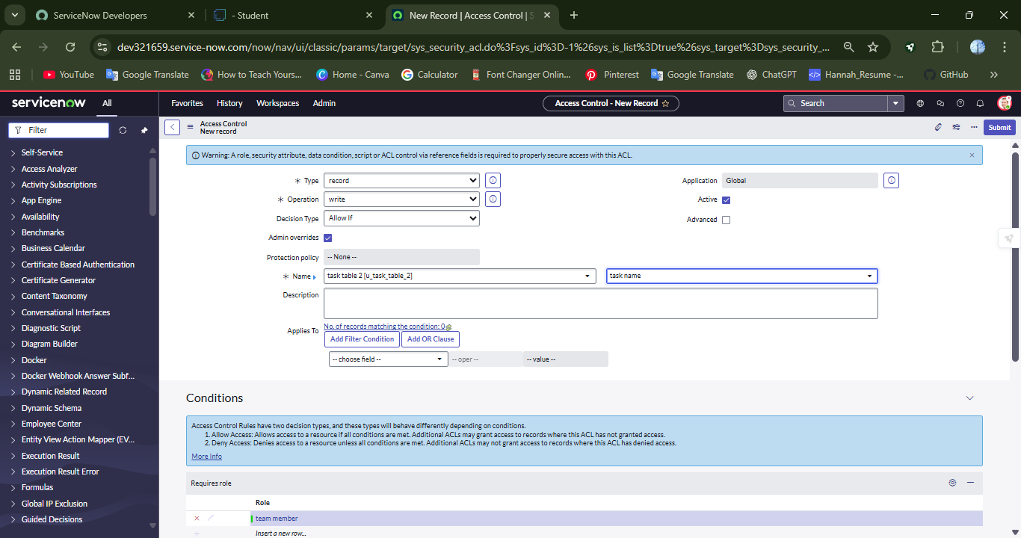

**Milestone 9 : Flow**

**Activity 1: Create a Flow to Assign operations ticket to group**

1. Click **“All”**
2. Search for Flow Designer under Process Automation.
3. After opening Flow Designer, click **“New”** and select **“Flow”**
4. Under flow properties, give flow name as “task table”
5. Application should be Global
6. Click **“Build Flow”**

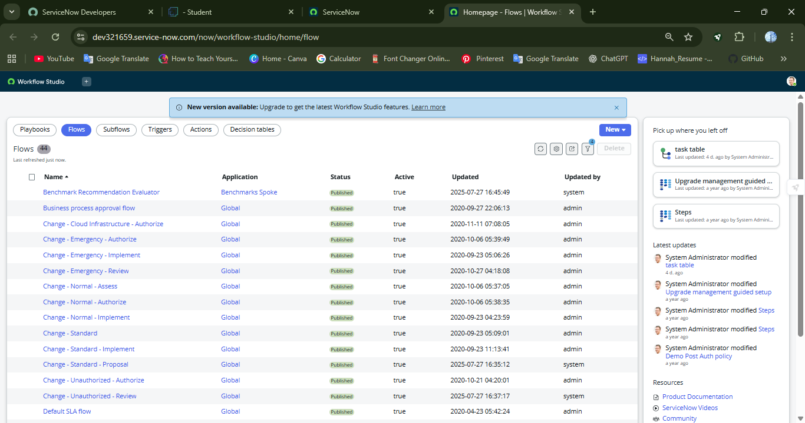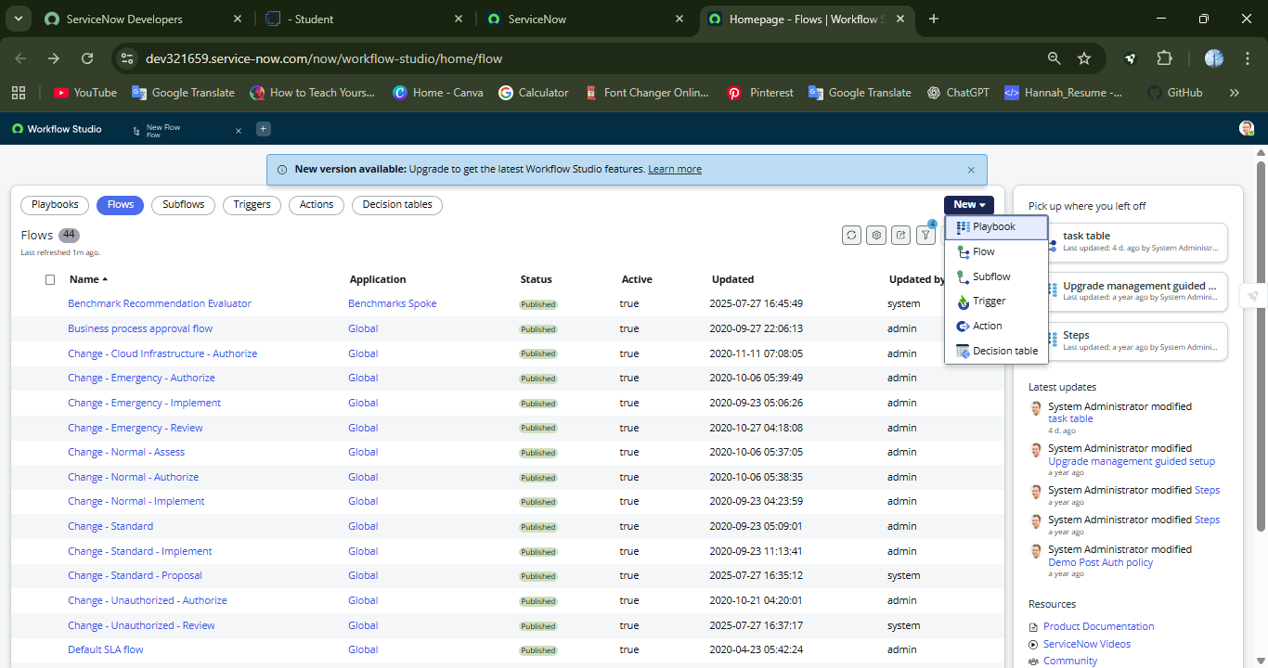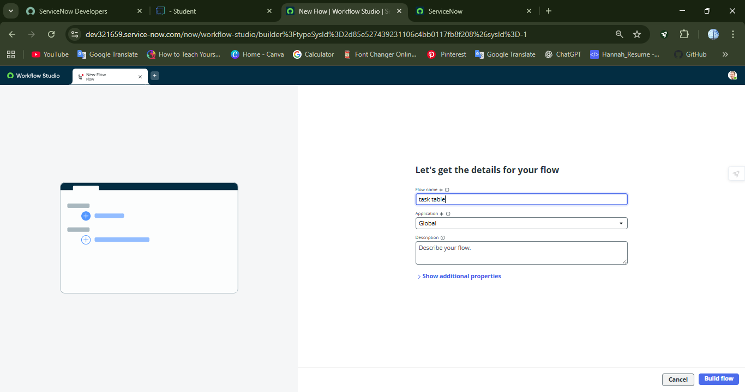

**next step:**

1. Click on Add a trigger
2. Select the trigger in that Search for “create record” and select that.
3. Give the table name as “task table ”.
4. Give the Condition as

Field: status

Operator: is

Value: in progress

Field: comments

Operator: is

Value: feedback

Field: assigned to

Operator: is

Value: bob

1. Click **“Done”**

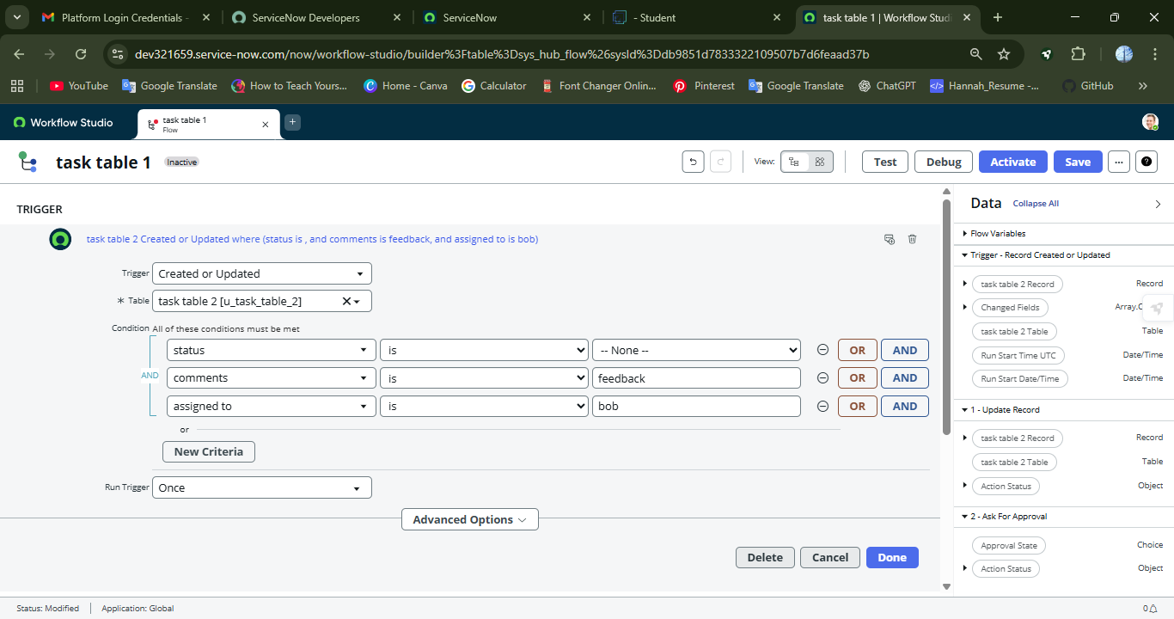

**Next step:**

1. Click on Add an action.
2. Select action in that ,search for “ update records”.
3. In Record field drag the fields from the data navigation from Right Side(Data pill)
4. Table will be auto assigned after that
5. Add fields as “status” and value as “completed”
6. Click on Done.

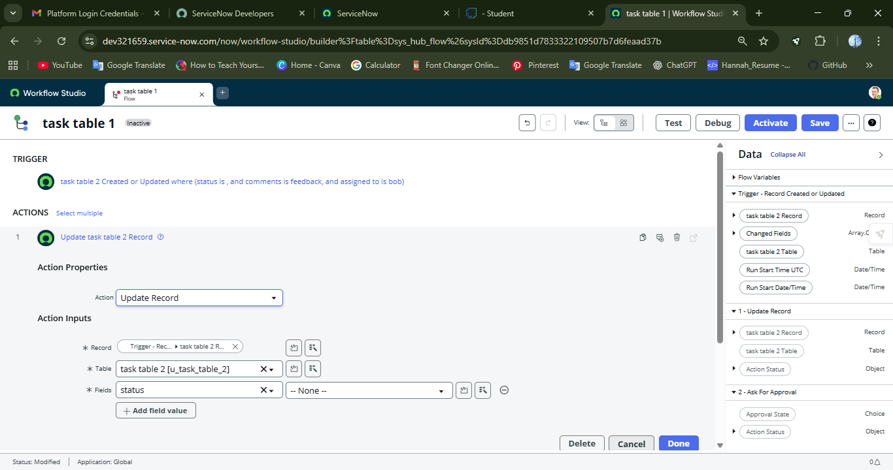

**Next step:**

1. Now under Actions.
2. Click on Add an action.
3. Select action in that ,search for “ ask for approval ”.
4. In Record field drag the fields from the data navigation from Right side
5. Table will be auto assigned after that
6. Give the approve field as “ status”
7. Give approver as alice p

8. Click on Done.

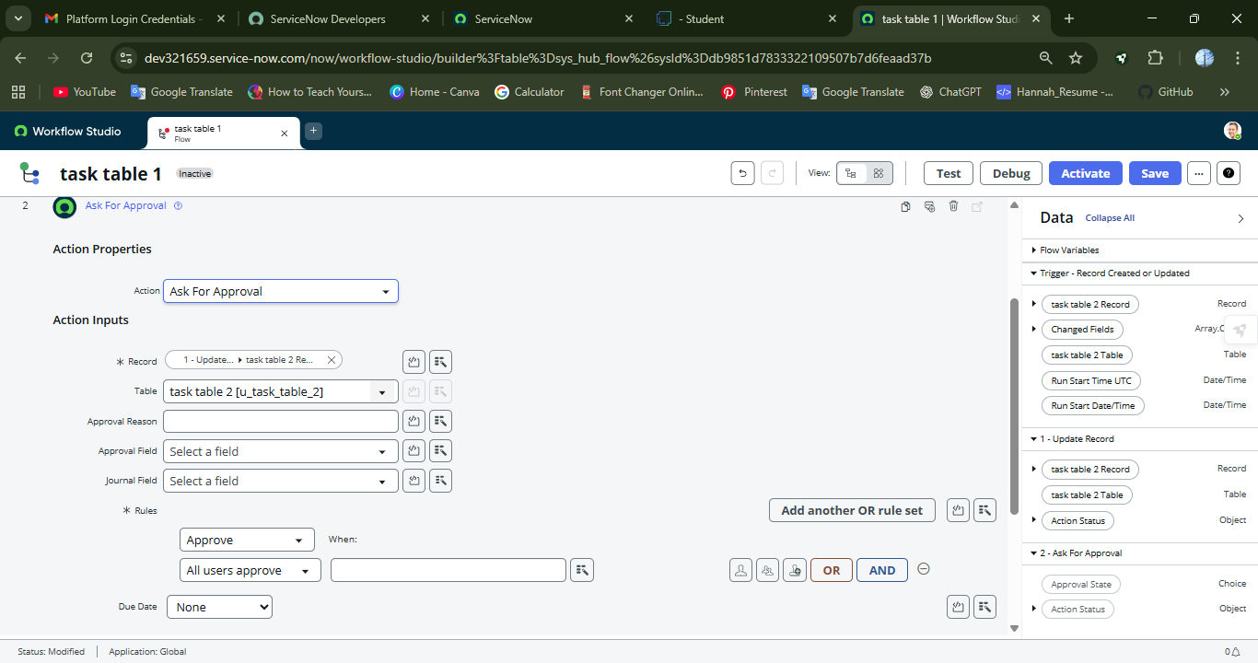

9. Go to task table in the **“All”**

10. In the table of assigned to, write **“Bob”**

11. Click Submit

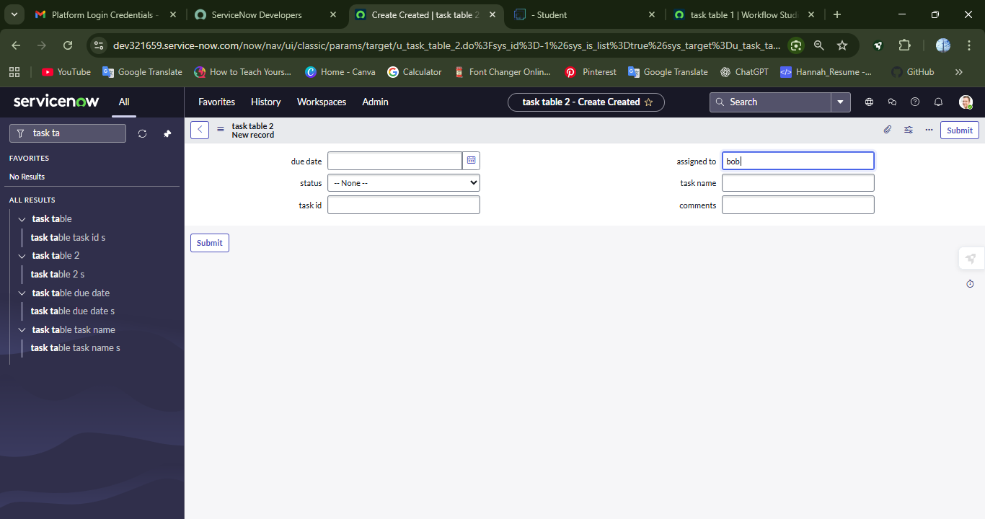

**Conclusion:**

This scenario highlights a structured approach to project management, showcasing the roles of Alice and Bob within a defined workflow. With Alice's oversight and Bob's execution, the team effectively collaborates to ensure project success. The use of tables organizes key information, facilitating easy tracking of projects, tasks, and progress updates. Overall, this system promotes accountability, enhances communication, and leads to the successful completion of projects.